**Lab-1**

1. Write a query to display the names (first_name, last_name) using alias name “First Name", "Last Name". 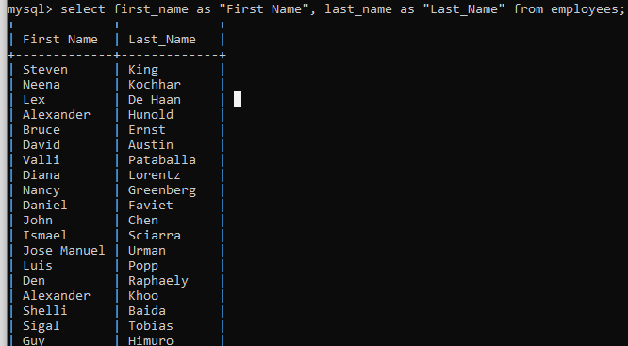

2. Write a query to get unique department ID from employee table.

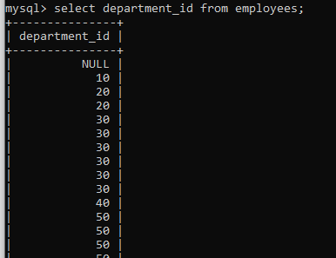

3. Write a query to get all employee details from the employee table order by first name, descending.

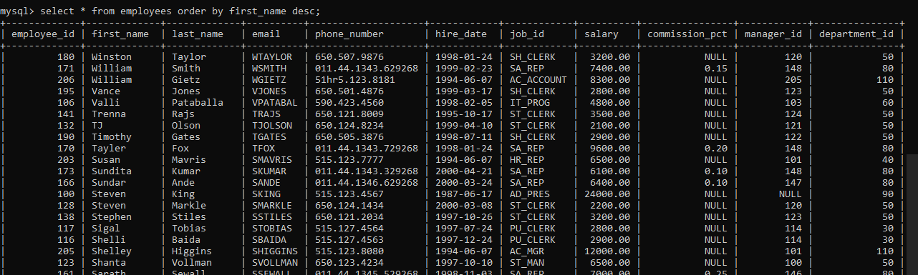

4. Write a query to get the employee ID, names (first_name, last_name), salary in ascending order of salary. 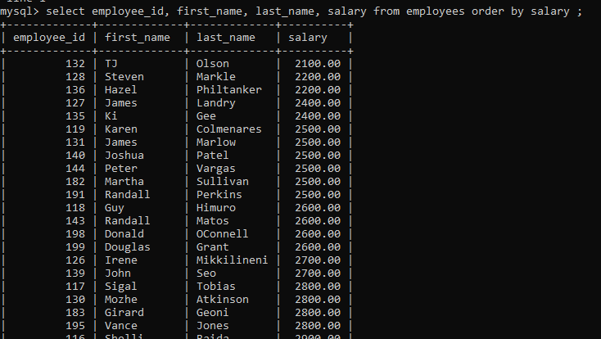

5. Write a query to get the total salaries payable to employees.

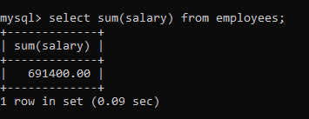

6. Write a query to get the maximum and minimum salary from employees table.

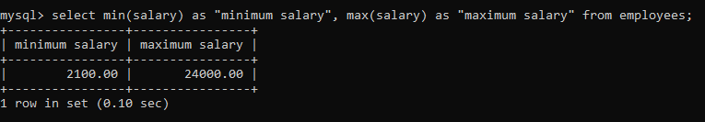

7. Write a query to get the average salary and number of employees in the employees table.

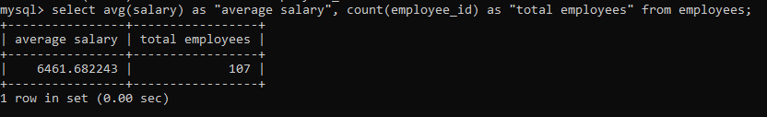

8. Write a query to get the number of jobs available in the employees table.

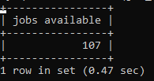

9. Write a query get all first name from employees table in upper case.

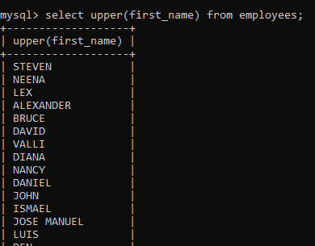

10.Write a query to select first 10 records from a table.

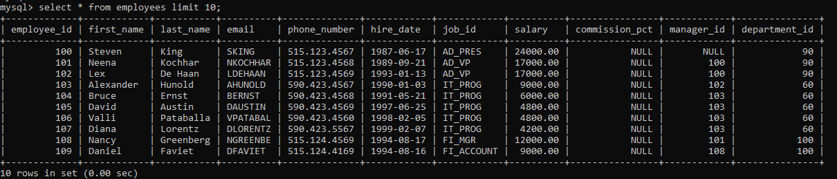

11.Write a query to select 3rd & 4th record of employees table.

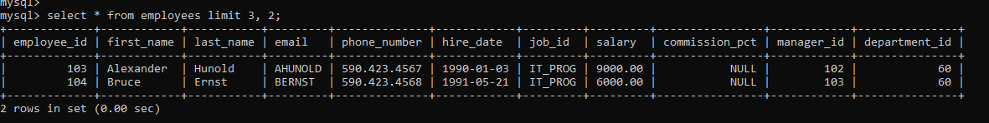

12.Write a query to select 2nd last record of employees table.

